The Digestive System: Anatomy Review

- List two main divisions of the digestive system.
  - _____________________
  - _____________________
- The four main layers of the digestive tract wall are
  - ___________
  - ___________
  - ___________
  - ___________
- Label the diagram below with the four main layers you listed in question 6.
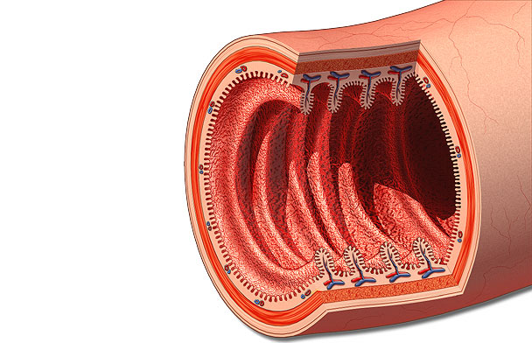
- The mucosa includes a type of columnar ________that forms the inner lining of the lumen
- Blood and lymph vessels of the mucosa are found in its ______ _______ connective tissue layer.
- The function of epithelial goblet cells is to secrete ________.
- _________ cells of the mucosa secrete hormones into the blood.
- Absorption of nutrients occurs through the mucosal epithelium and into either _______ or ______ vessels.
- Using the following diagram, label the vessels you listed in the previous question.
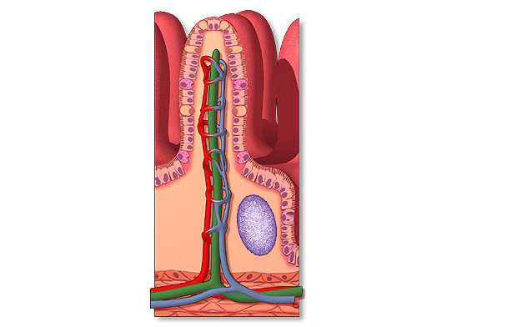
- The built-in (intrinsic) network of nerve cells in the submucosa is the ______ ______.
- The two types of movements produced by contractions of the muscularis externa are ____________ and ____________.
- List the four regions of the stomach:
  - __________
  - __________
  - __________
  - __________
- List the three sheets of muscle in the stomach’s muscularis externa:
  - ____________
  - ____________
  - ____________
- Label the three sheets of muscle in the stomach’s muscularis externa in the diagram below.
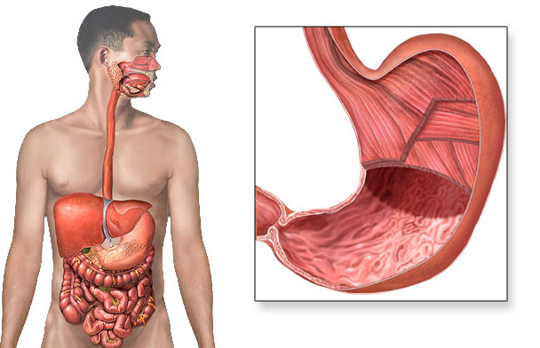

- List, in order from the pylorus to the colon, the three regions of the small intestine:
  - ____________
  - ____________
  - ____________
- From largest to smallest, list the three modifications of the small intestine’s inner wall that function to increase surface area:
  - _____________
  - _____________
  - _____________
- Label two of the modifications of the intestine to increase surface area in the diagram below.
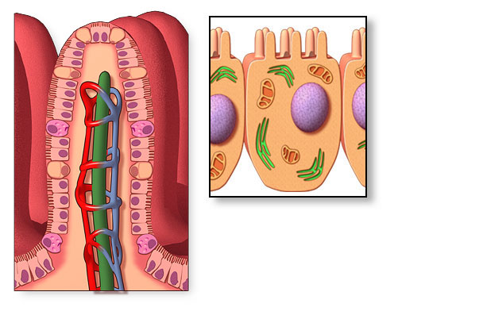
- The microvilli of the small intestine’s epithelial cells form the ______ border.
- Starting from the ileocecal valve, trace the path of undigested material through the large intestine.
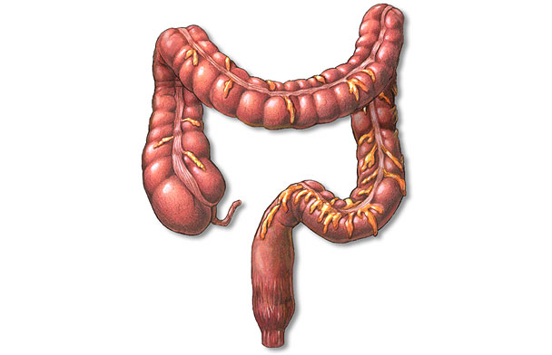
- List the six sphincters of the digestive tract:
  - _______
  - _______
  - _______
  - _______
  - _______
- The single digestive function of the liver is to produce _____.
- The main digestive enzyme-producing organ in the body is the ______.
- Three pairs of _____ _____ function to moisten food in the mouth.

