The Digestive System: Motility

- The process by which food is received into the GI tract via the mouth is called _____________________.
- The esophagus is digestive in function.
  - True
  - False
- Swallowing has both voluntary and involuntary components
  - True
  - False
- The function of the epiglottis is to prevent a bolus from entering the _____.
- The hormone ______ regulates gastric secretion during the gastric phase of digestion.
- The hormone _______ causes the gall bladder to contract and release bile into the small intestine.
- The ________ reflex describes the communication between the intestine and the stomach.
- The motility process illustrated below is _________.
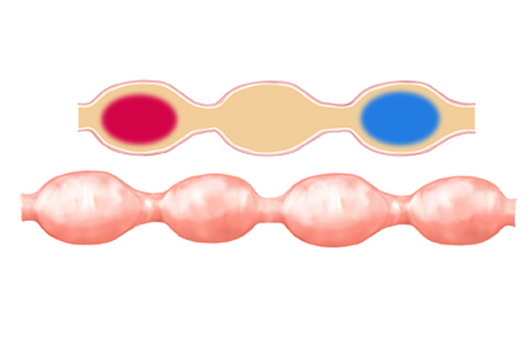

- Segmentation moves chyme in only one direction.
  - True
  - False
- List the two major functions of the large intestine.
  - _______________________
  - _______________________
- Pockets formed by the contractions of the transverse and descending colon musculature are called ___________.
- Sustained, intense propulsive peristaltic contractions of the large intestine are called __________ ___________.
- Which of the following is under voluntary control?
  - Internal anal sphincter
  - External anal sphincter
- Place the following labels on the large intestine figure below:
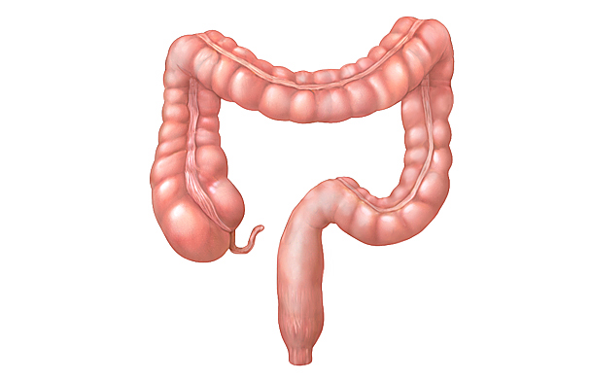
Cecum, ascending colon, transverse colon, descending colon, sigmoid colon, rectum, haustra, appendix
- The ________ reflex stimulates mass movements of the colon.

