The Digestive System: Secretion

- Label the parotid, submandibular, and sublingual salivary glands in the figure below:
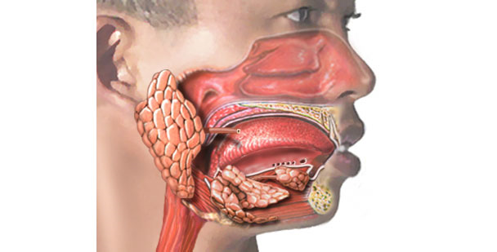
2. The esophagus secretes digestive enzymes.
  - True
  - False
3. The four main components of gastric juice are:
  - _________
  - _________
  - _________
  - _________
4. List the only two substances that are absorbed across the stomach’s mucosal epithelium
- _________
- _________
5. Without _______ _______, vitamin B₁₂, necessary for normal RBC development, can not be absorbed by the intestine.
6. Match the following pairs of terms:
CCK bicarbonate pancreatic juice
Secretin enzyme-rich pancreatic juice
7. Intestinal digestive enzymes that are embedded in the epithelial microvilli membranes are called ________ ________ enzymes.
8. The intestinal hormone _____ causes contraction of the gall bladder and release of bile into the duodenum.
9. _______ _______protects the wall of the large intestine from mechanical damage and from damage by bacterial acid.

